**A PROJECT REPORT**

**ON**

**"LPG GAS LEAKAGE DETECTION SYSTEM”**

SUBMITTED IN PARTIAL FULFILLMENT OF THE REQUIREMENTS FOR THE AWARD OF

**DIPLOMA IN**

**DEPARTMENT OF COMPUTER SCIENCE AND ENGINEERING**



**SUBMITTED TO**

**BOARD OF TECHNICAL EDUCATION, RAJASTHAN**

**SUBMITTED BY**

|  |  |
| --- | --- |
| **Name of Student(s)** | **Enrollment No.** |
| **1.** Ashish | CS20200007/008 |
| **2.** Jahanvi Mathur | CS20200024/008 |
| **3.** Om Prakash Yadav | CS20200038/008 |
| **4.** Ujjwal Karn | MP/CS20200020/008 |

**GUIDED BY**

Mr. GIRIRAJ VYAS

**GOVERNMENT RAMCHANDRA KHAITAN**

**POLYTECHNIC COLLEGE, JAIPUR**

**2022-23**



**GOVERNMENT RAMCHANDRA KHAITAN**

**POLYTECHNIC COLLEGE, JAIPUR**

**CERTIFICATE**

**This is to certify that the project report entitled “LPG Gas Leakage Detection System” was successfully completed by Student of sixth semester Diploma in (Computer Science and Engineering).**

|  |  |
| --- | --- |
| **1.** Ashish | CS20200007/008 |
| **2.** Jahanvi Mathur | CS20200024/008 |
| **3.** Om Prakash Yadav | CS20200038/008 |
| **4.** Ujjwal Karn | MP/CS20200020/008 |

**in partial fulfillment of the requirements for the award of the Diploma in Computer Science and Engineering and submitted to the Department of Computer Science and** **Engineering of Government Ramchandra Khaitan Polytechnic College, Jaipur work carried out during a period for the academic year 2022-23 as per curriculum.**

Name of Guide Name of HOD

(Mr. Giriraj Vyas) (Dr. Sunil Sharma)

External Examiner

**ACKNOWLEDGMENGT**

This project is done as a semester project, as a part course titled

**“LPG Gas Leakage Detection System”.**

We are really thankful to our course the Principal **Mr. S.M Ali** and the HOD **Dr. Sunil Sharma**, **Department of Computer Science and Engineering**, Government Ramchandra Khaitan Polytechnic College, Jaipur for his invaluable guidance and assistance, without which the accomplishment of the task would have never been possible.

We also thank **Mr. Giriraj Vyas** for giving this opportunity to explore into the real world and realize the interrelation without which a project can never progress. In our present project we have chosen the topic- **“LPG Gas Leakage Detection System”.**

We are also thankful to parents, friend and all staff of **Department of Computer Science and Engineering,** for providing us relevant information and necessary clarifications, and great support.

**ABSTRACT**

The gas detection system project presented in this report utilizes an Arduino microcontroller, MQ5 gas sensor, relay module, and exhaust fan to create a proactive and efficient solution for detecting flammable or hazardous gases. The system continuously monitors the gas concentration and triggers the activation of the exhaust fan when gas levels exceed safe thresholds.

The objective of this project is to enhance safety in various environments by promptly detecting gas leaks and mitigating potential risks. The system's hardware components are interconnected, and the Arduino is programmed to read gas sensor data, compare it with predefined thresholds, and control the relay module accordingly. This activates the exhaust fan, facilitating the ventilation of the area and reducing the risk of gas-related incidents.

The survey conducted as part of this project identified common applications such as residential, commercial, industrial, laboratory, HVAC systems, gas storage facilities, and commercial kitchens. The system's flexibility and adaptability make it suitable for a wide range of environments where gas detection and safety are paramount.

The hardware requirements for this project include an Arduino Uno, MQ5 gas sensor, relay module, exhaust fan, and associated connecting wires. The circuit diagram provides a clear visual representation of the interconnections between these components.

The project's working process involves sensor calibration, hardware setup, Arduino programming, and safety precautions. The gas detection system's efficacy is dependent on accurate calibration, proper placement of the gas sensor, and integration with the exhaust fan through the relay module.

The applications of this gas detection system are significant, encompassing residential, industrial, and commercial settings. By promptly detecting gas leaks and activating the exhaust fan, the system minimizes the risks associated with flammable or hazardous gases, safeguarding individuals, properties, and the environment.

**TABLE OF CONTENTS**

**CHAPTER PAGE**

Chapter1-Introduction……………………….………………………….1

Chapter2-Survey……………………….….………………...….….…...2

Chapter3-Hardware Requirement….….…………...……….….….….…4

Chapter4-Block Diagram…………….….………………….….….….…5

Chapter5-Working……...……………….….……………….….….….…6

Chapter6-Circuit Diagram………………………………….….….……15

Chapter7-Applications………………………………….….….….…….16

Chapter8-Experimantal Result………………………….….….….….…19

**CONCLUSON……………….……………………………….….….…20**

**REFERENCES……….….…………………………………………….21**

**COSTING……………………………………….….………………….22**

**PROGRAM CODE……………………………………………………23**

**LIST OF FIGURES**

**FIGURE NO. FIGURE NAME PAGE NO.**

Fig – 4.1 Block Diagram 5

Fig-5.1 Arduino 7

Fig-5.2 MQ5 Sensor 9

Fig-5.3 Relay Module 9

Fig-5.4 Exhaust Fan 10

Fig-5.5 LED 11

Fig-5.6 Buzzer 12

Fig-6.1 Circuit Diagram 15

Fig-7.1 Gas Detector 16

Fig-7.2 Gas Detector 16

Fig-7.3 Gas Detector 16

Fig-7.4 Gas Detector 17

Fig-7.5 Gas Detector 17

Fig-7.6 Gas Detector 17

Fig-7.7 Gas Detector 18

Fig-8.1 Result 19

Fig-8.2 Result 19

**CHAPTER-1**

**INTRODUCTION**

* Inspiration:

This is inspired by the many gas cylinder blast accidents that have caused a large amount of loss of life and cannot be forgotten such as "4 killed, over 60 wedding guests injured in gas cylinder blast in Jodhpur", "Three people were killed and four injured when the roof of their house collapsed after an LPG cylinder exploded in Rajasthan's Chittorgarh" etc.

Apart from this, there are many such cases. We have been inspired to make this project to avoid these accidents.

* Objective:

Our objective is to create a gas detection system that will automatically detect when there is a gas leak in the house and cut off the light of the house and run the exhaust fun automatically.

* Problem Statement:

Our problem is to create a IOT device to work accidents caused by gas cylinders, so that it can be saved without any help from any person. And there is no harm to anyone, even if someone does not know, then he should know before any accident occurs.

**CHAPTER-2**

**SURVEY**

The objective of this survey is to explore existing projects and research related to gas detection system that organizations can make informed decisions regarding the selection, installation, and maintenance of gas detection equipment. The objective is to enhance the safety and well-being of personnel, protect assets, and minimize the risks associated with the presence of flammable or hazardous gases in the facility.

* **Gas detection system techniques:**
* Catalytic Combustion: This technique involves using a catalytic bead sensor that detects the presence of flammable gases by measuring the heat generated during their combustion.
* Infrared (IR) Absorption: Infrared gas detectors utilize the principle of infrared light absorption to detect the presence of certain gases. Each gas has a unique absorption spectrum, and the detector measures the amount of infrared light absorbed by the gas to determine its concentration.
* Semiconductor Sensors: Semiconductor gas sensors utilize a metal oxide semiconductor material that changes its electrical resistance when it comes into contact with a target gas.
* **Decision-Making Algorithms:**
* Reactive Algorithms: Reactive algorithms enable immediate response to detected LPG Gas , triggered buzzer to true on.
* light cut Algorithms: it will automatically detect when there is a LPG leak in the house and cut off the light of the house.
* automatically exhaust on algorithm: When the light is cut off, the exhaust will automatically go on and the light will automatically connect as soon as the gas leakage is detected..
* **Applications:**
* Industrial Safety: LPG detection systems are widely used in industrial settings to monitor and detect hazardous gases. Industries such as oil and gas, petrochemical, chemical manufacturing, mining, and construction utilize gas detection systems to protect workers from potentially toxic or flammable gases. These systems help identify leaks, prevent accidents, and enable timely evacuation or safety measures.
* Residential and Commercial Buildings: LPG detection systems are commonly used in residential and commercial buildings where LPG is used for cooking, heating, or other purposes. These systems ensure the early detection of gas leaks to prevent accidents, gas-related incidents, and potential explosions. They provide an added layer of safety, particularly in areas where LPG cylinders or piped gas systems are installed.
* Restaurants and Food Service Establishments: LPG is extensively used in restaurants, hotels, cafeterias, and other food service establishments for cooking. LPG detection systems help monitor the kitchen areas and alert the staff in case of any leaks or gas-related hazards. These systems are crucial for maintaining a safe working environment and protecting the customers and staff from potential dangers.

**CHAPTER-3**

**HARDWARE REQUIREMENT**

Based on the survey and analysis of multiple projects, the following hardware components have been shortlisted for fulfilling the requirements of LPG gas detection system.

* **Microcontroller:** Arduino Uno
* **Sensor**: MQ5 Sensor
* Relay Module (5v)
* Dc Exhaust fan without brush (5v)
* Dc LED (5v)
* Buzzer (5v)
* Battery & Switch (9v)
* Motor
* Jumper wires

**CHAPTER-4**

**BLOCK DIAGRAM**

The Basic block diagram of the LPG gas detection system is shown in above figure. Mainly this block diagram consists of the following essential blocks.

1. Arduino uno

2. MQ5 sensor

3. Relay module

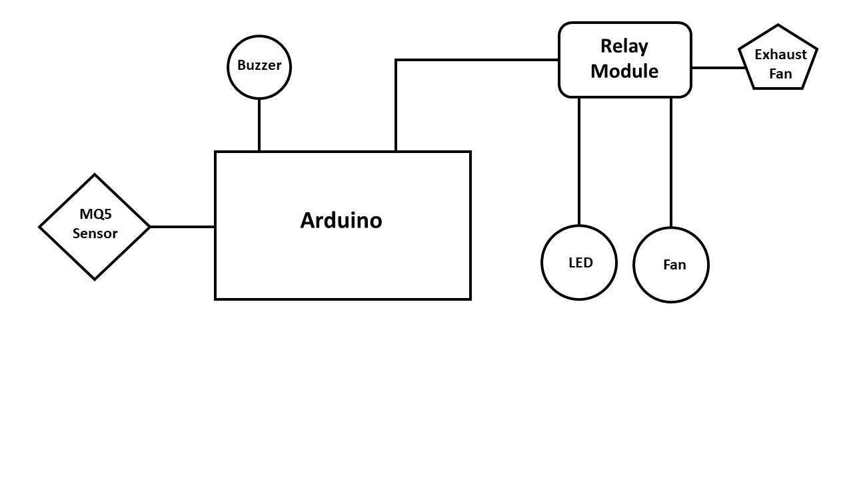

Fig – 4.1 Block Diagram

* **Arduino uno**

Arduino Uno is an AT Mega 328p Microcontroller based prototyping board. It is an open**-**source electronic prototyping platform that can be used with various sensors andactuators. It is used for controlling all the operation and assign task to each device.

* **Mq5 sensor**

The MQ-5 gas sensor is a popular semiconductor-based sensor module used for detecting and measuring the concentration of various gases in the atmosphere. It is specifically designed to detect flammable gases, including liquefied petroleum gas (LPG), natural gas, and propane.

* **Relay module**

A 5V relay module is an electronic component used to control high-power devices or electrical circuits using a low-power control signal, typically from a microcontroller or other electronic device. The relay module acts as a switch that can turn on or off the power supply to the connected load.

**CHAPTER-5**

**WORKING**

**Working principle:**

The working process for a gas detection system using an Arduino, MQ5 gas sensor, relay module, and exhaust fan involves the following steps:

1. Sensor Calibration: Begin by calibrating the MQ5 gas sensor to ensure accurate gas detection. Follow the manufacturer's instructions for calibrating the sensor based on the target gas you want to detect.
2. Hardware Setup: Connect the components as follows:
   * Connect the MQ5 gas sensor's VCC pin to the 5V pin of the Arduino.
   * Connect the MQ5 gas sensor's GND pin to the GND pin of the Arduino.
   * Connect the MQ5 gas sensor's AOUT pin to an analog input pin of the Arduino (e.g., A0).
   * Connect the relay module's input pin to a digital output pin of the Arduino (e.g., Pin 2).
   * Connect the relay module's output to the power supply of the exhaust fan.
3. Arduino Programming:
   * Set up the analog input pin for reading data from the MQ5 gas sensor.
   * Define the digital output pin for controlling the relay module.
   * In the main loop, read the analog input value from the gas sensor using the "analogRead" function.
   * Compare the sensor reading with a predefined threshold to determine if the gas concentration exceeds the safety level.
   * If the gas concentration exceeds the threshold, activate the relay module by setting the digital output pin to HIGH, which will power on the exhaust fan.
   * If the gas concentration is below the threshold, deactivate the relay module by setting the digital output pin to LOW, turning off the exhaust fan.
4. Safety Precautions: Ensure that the exhaust fan is properly installed and positioned to effectively vent out the gas in case of detection. Also, consider incorporating additional safety measures such as gas alarms or notification systems to alert individuals in the vicinity.
5. Testing and Monitoring: Once the system is set up, test it by introducing the target gas or simulating its presence. Observe the behavior of the gas sensor, relay module, and exhaust fan. Continuously monitor the system to ensure proper functioning and responsiveness to gas detection.

**Arduino UNO:**

Arduino Uno is a popular microcontroller board that has gained immense popularity among electronics enthusiasts, hobbyists, and professionals alike. It is an open-source platform that allows users to develop and prototype various electronic projects quickly and easily. The Arduino Uno board is based on the ATmega328P microcontroller and comes with a range of input and output pins, making it versatile and flexible for a wide range of applications.

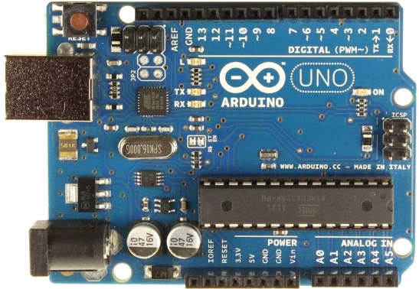

Fig-5.1 Arduino

The Arduino Uno board features a compact design with a set of digital and analog input/output pins, which can be used to connect various components such as sensors, actuators, displays, and more. It has 14 digital input/output pins, among which 6 can be used as pulse-width modulation (PWM) outputs, enabling users to control devices with varying power levels. Additionally, the board provides 6 analog input pins for reading analog signals, making it suitable for applications that require precise measurements.

One of the key features of Arduino Uno is its simplicity and ease of use. The board can be programmed using the Arduino Integrated Development Environment (IDE), which provides a user-friendly interface for writing, compiling, and uploading code to the board. The Arduino programming language is based on C/C++, but it simplifies the process by providing a set of libraries and functions that abstract the complexities of microcontroller programming.

Arduino Uno is compatible with a wide range of sensors, modules, and shields, which are pre-built circuit boards that can be easily attached to the main board, expanding its capabilities. This allows users to interface with a variety of devices and components without the need for complex circuit design or soldering.

The power supply for the Arduino Uno can be provided through a USB connection or an external power source, such as a battery or an AC-to-DC adapter. It has a built-in voltage regulator that ensures stable and regulated power supply to the microcontroller and connected devices.

**MQ5 GAS SENSSOR:**

The MQ-5 gas sensor is a popular gas sensor module used to detect combustible gases in the air. It can detect gases such as LPG, propane, methane, hydrogen, and alcohol, among others. The sensor is based on the principle of catalytic combustion, whereby the presence of a combustible gas causes a reaction that changes the resistance of the sensor.

The MQ-5 sensor is made up of a ceramic sensing element coated with a thin layer of catalytic material. When a combustible gas comes in contact with the sensing element, it is oxidized and the resistance of the element changes, which is proportional to the concentration of the gas.

The sensor requires a heating element to maintain a constant temperature, usually around 200°C, which is necessary for the catalytic reaction to take place. The sensor output can be read using an analog-to-digital converter (ADC) to determine the gas concentration.

The MQ-5 sensor is commonly used in gas detectors, alarms, and monitoring systems, as well as in the automotive and industrial fields. It is important to note that the sensor is not suitable for detecting gases that do not undergo catalytic combustion, such as carbon monoxide. Additionally, the sensor may be sensitive to humidity and other environmental factors, which can affect its accuracy.

The MQ-5 gas sensor requires a voltage of around 5V to operate, and its output is an analog voltage signal that varies with the concentration of the gas being detected. The output signal can be read and processed by a microcontroller or other electronic circuit to trigger alarms, control ventilation systems, or display the gas concentration on a screen.

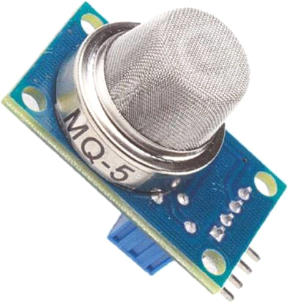

Figure 5.2 mq5 sensor

**RELAY MODULE(5V):**

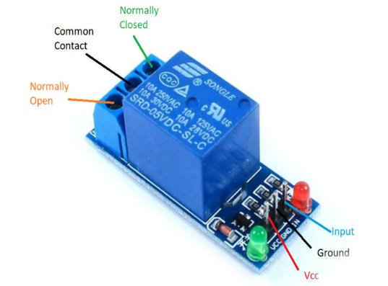

Figure 5.3 Relay module

A relay module is an electronic device that allows low-voltage signals to control high-voltage circuits. It typically consists of a relay, which is an electrically operated switch, and a circuit board with additional components such as transistors, diodes, and resistors.

The 5V in the term "relay module (5V)" refers to the operating voltage of the relay module. In other words, the module requires a 5-volt power supply to operate.

Relay modules are commonly used in industrial control systems, home automation, and automotive applications to control electrical devices such as motors, lights, and appliances. They provide a safe and reliable method of switching high-voltage circuits with low-voltage signals, which helps to protect sensitive control electronics and prevent electrical shocks and fires.

When a low-voltage signal is applied to the relay module's control input, it activates the relay, which in turn switches the high-voltage circuit on or off. This allows for remote control of electrical devices and can help to automate processes and improve efficiency.

**Exhaust fan (5v):**

A 5V DC exhaust fan without brushless technology is a type of fan that uses a brushed DC motor to power the blades. Unlike brushless fans that use electronic circuitry to control the motor, these fans use physical brushes to transmit electricity to the rotating armature.

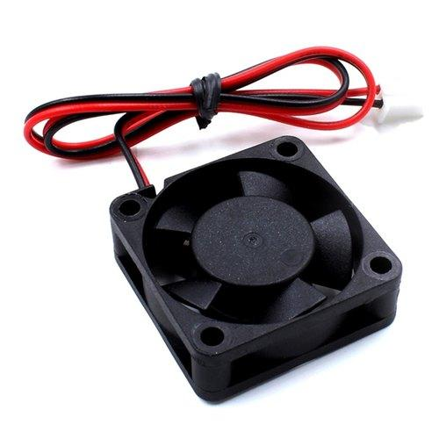

Fig-5.4 Exhaust fan

While these fans are cheaper to manufacture than brushless fans, they have some drawbacks. The brushes can wear out over time and require replacement, which can be costly and inconvenient. They can also generate more electrical noise than brushless fans due to the physical contact between the brushes and the armature.

Despite these limitations, 5V DC exhaust fans without brushless technology are still widely used in various applications, such as cooling electronic components in computers, audio amplifiers, and other devices that require air flow to dissipate heat. Their simplicity and low cost make them a popular choice in situations where noise and durability are not major concerns.

**SMD LED:**

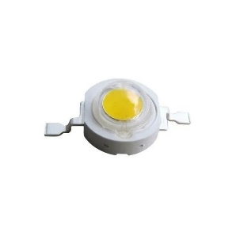

Fig-5.5 SMD LED

SMD LED stands for Surface Mount Device Light Emitting Diode. It is a type of LED that is designed to be mounted onto a printed circuit board (PCB) without the need for leads or wires. SMD LEDs are popular due to their compact size, energy efficiency, and versatility, making them a popular choice for various lighting applications, including consumer electronics, automotive lighting, and general lighting.

SMD LEDs are manufactured using semiconductor materials, including gallium nitride (GaN), indium gallium nitride (InGaN), and aluminum indium gallium phosphide (AlInGaP). These materials are deposited onto a substrate, such as a sapphire or silicon wafer, using a process called epitaxy. The epitaxial layers are then processed to create individual LEDs, which are typically very small in size, ranging from 0.4mm x 0.2mm (0402) to 5.0mm x 5.0mm (5050).

SMD LEDs come in a range of colors, including red, green, blue, yellow, and white. White SMD LEDs can be manufactured using several techniques, including using a blue LED with a phosphor coating, combining red, green, and blue LEDs, or using a combination of yellow and blue LEDs.

One of the primary advantages of SMD LEDs is their energy efficiency. They consume less power and generate less heat than traditional incandescent bulbs, making them an ideal choice for use in portable electronic devices and applications where power consumption is critical. Additionally, they have a long lifespan, typically exceeding 50,000 hours, and are resistant to shock and vibration, making them suitable for use in rugged environments.

SMD LEDs are typically mounted onto a PCB using a process called surface mount technology (SMT). SMT involves applying solder paste to the pads on the PCB, placing the SMD LEDs onto the paste, and then heating the assembly to melt the solder and secure the LEDs in place. This process is more efficient than traditional through-hole mounting, which involves inserting leads through holes in the PCB and soldering them in place.

**Buzzer (5V):**

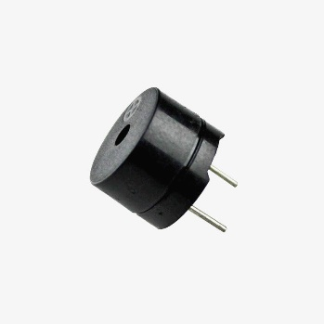

Fig-5.6 buzzer

A buzzer (5V) is an electronic component that generates a sound when an electric current is passed through it. It typically operates at 5 volts, which is a common voltage level in many electronic circuits.

The buzzer consists of a piezoelectric element that vibrates when an electrical signal is applied to it. This vibration creates sound waves that can be heard as a beep or a tone. Buzzer (5V) are commonly used in electronic devices such as alarms, timers, and notification systems, where an audible alert is needed to draw attention to a specific event or action.

Buzzer (5V) can be controlled by an electronic circuit that applies a specific frequency and duration of electrical signals to the buzzer. By adjusting the frequency and duration of the signals, the tone and volume of the buzzer can be modified to suit the application. Some buzzers may also have additional features, such as adjustable volume or different types of tones or alarms.

**Battery:**

A 9V battery is a compact and portable power source commonly used in a wide range of electronic devices. It is a rectangular-shaped battery with two terminals, typically a positive terminal (+) and a negative terminal (-). Here are a few key points about 9V batteries:

1. Voltage: As the name suggests, a 9V battery provides a nominal voltage of 9 volts. This relatively higher voltage makes it suitable for powering devices that require a higher power supply, such as smoke detectors, portable radios, guitar effects pedals, and some small electronic circuits.
2. Size and Shape: 9V batteries are generally rectangular in shape, with dimensions of approximately 48.5mm x 26.5mm x 17.5mm. This distinctive shape allows them to fit into battery compartments designed specifically for 9V batteries.
3. Battery Chemistry: 9V batteries are available in different chemistries, including alkaline, lithium, and rechargeable variants. Alkaline 9V batteries are the most commonly used and readily available, offering a decent amount of power for various devices. Lithium 9V batteries provide longer-lasting power and are often used in applications where extended battery life is required. Rechargeable 9V batteries are also available, allowing for multiple uses and reducing waste.
4. Connector Type: 9V batteries typically have a snap-style connector at the top, which consists of a positive terminal and a negative terminal. This connector is compatible with devices designed to accept 9V batteries and ensures a secure electrical connection.
5. Usage Considerations: When using 9V batteries, it is important to consider their capacity and expected lifespan. Higher power devices can drain 9V batteries relatively quickly compared to devices with lower power requirements. It's advisable to keep spare batteries on hand, especially in critical applications or situations where a loss of power can have significant consequences.
6. Environmental Impact: Like other batteries, 9V batteries should be disposed of properly to minimize their environmental impact. Many regions have recycling programs for batteries, and it is recommended to take advantage of these programs to ensure responsible disposal.

Overall, 9V batteries are versatile power sources commonly used in a wide range of electronic devices. Their higher voltage and compact size make them suitable for various applications, and they are readily available in different chemistries to meet specific power requirements.

**CHAPTER-6**

**CIRCUIT DIAGRAM**

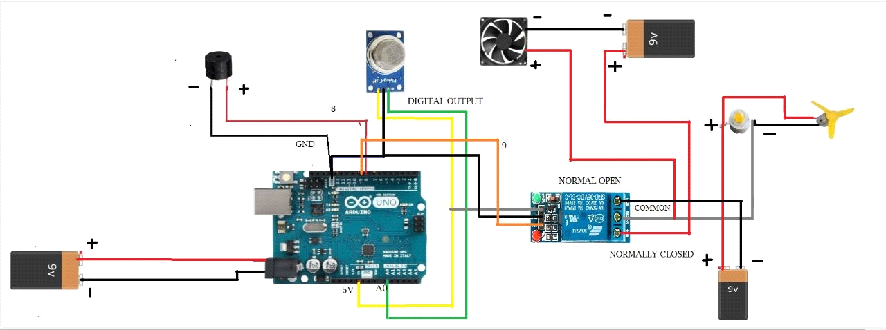

Fig-6.1 Circuit Diagram

* In This diagram We connect the buzzer's +VE & -VE to Arduino's digital pin 9 & GND.
* Now We connect Sensor’s GND , input,& VCC to Arduino's GND, A0 pin & 5v.
* we connect relay pins to Arduino. relay's GND, input & VCC to Arduino's GND, digital pin 8 & 5v.
* now, relay's normal open pin connect with the battery's -VE and the common pin connect to with the exhaust +VE and fan& led -VE,
* Now, we connect exhaust -VE to battery's -VE relay's module, normal close pin with battery's +VE.
* NOW, we connect the fan & led with the battery's +VE.

**CHAPTER-7**

**APPLICATIONS**

The gas detection system project utilizing an Arduino, MQ5 gas sensor, relay module, and exhaust fan has several practical applications, including:

1. 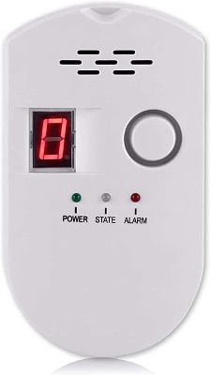**Home Safety:**

The system can be implemented in residential settings to detect flammable or hazardous gases such as natural gas, propane, or carbon monoxide. It provides an added layer of safety by activating the exhaust fan to remove the detected gas and prevent potential hazards.

Fig 7.1 Home Safety

1. 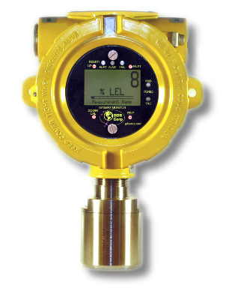**Industrial Environments:**

Gas detection systems using the MQ5 gas sensor can be deployed in industrial settings where the presence of gases poses significant risks. It helps in detecting leaks or build-up of gases in manufacturing plants, chemical facilities, or storage areas, allowing for prompt action and preventing accidents.

Fig 7.2 Gas detector

1. **Laboratories:**

Gas detection systems are essential in laboratory environments where various volatile substances and gases are handled. The system can detect the presence of harmful gases, ensuring the safety of personnel and preventing chemical exposure.

Fig 7.3 Gas detector

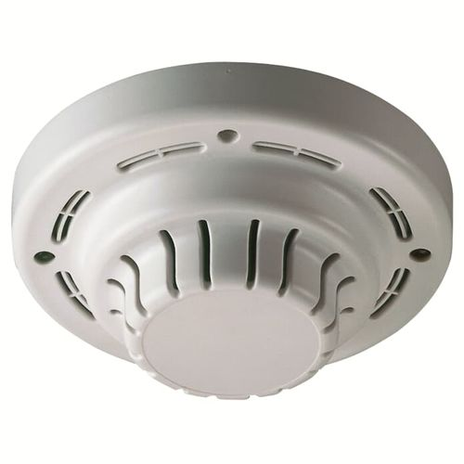

1. **Commercial Buildings:**

Implementing gas detection systems in commercial buildings, such as offices, shopping malls, or restaurants, helps ensure the safety of occupants. It provides early detection of gas leaks, allowing for prompt evacuation and necessary measures to mitigate risks.

Fig 7.4 Gas detector

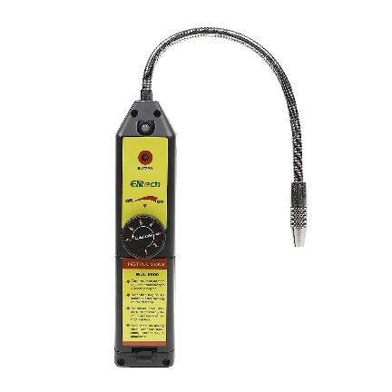

1. **HVAC Systems:**

The gas detection system can be integrated into heating, ventilation, and air conditioning (HVAC) systems. It aids in monitoring gas levels and activating the exhaust fan or ventilation system when gas concentrations exceed safe limits, ensuring a healthy indoor environment.

Fig 7.5 HVAC systems

1. 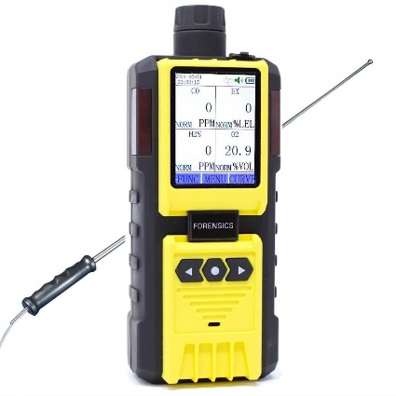**Gas Storage Facilities:**

Facilities that store compressed gases, such as gas cylinders or tanks, can benefit from a gas detection system. It helps in monitoring gas leaks, preventing potential explosions or accidents, and ensuring the safe storage and handling of gases.

Fig 7.6 Gas detector

1. 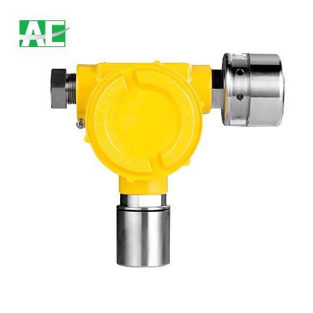**Commercial Kitchens:**

Gas detection systems are vital in commercial kitchens where natural gas or propane is used for cooking. The system can detect gas leaks from stoves, ovens, or gas lines, triggering the exhaust fan to maintain a safe working environment.

Fig 7.7 Gas detector

In all these applications, the gas detection system provides an automated and proactive approach to ensure safety by detecting the presence of gases, activating the exhaust fan, and mitigating potential risks associated with gas leaks or hazardous gas concentrations.

**CHAPTER-8**

**EXPERIMENTAL RESULT**

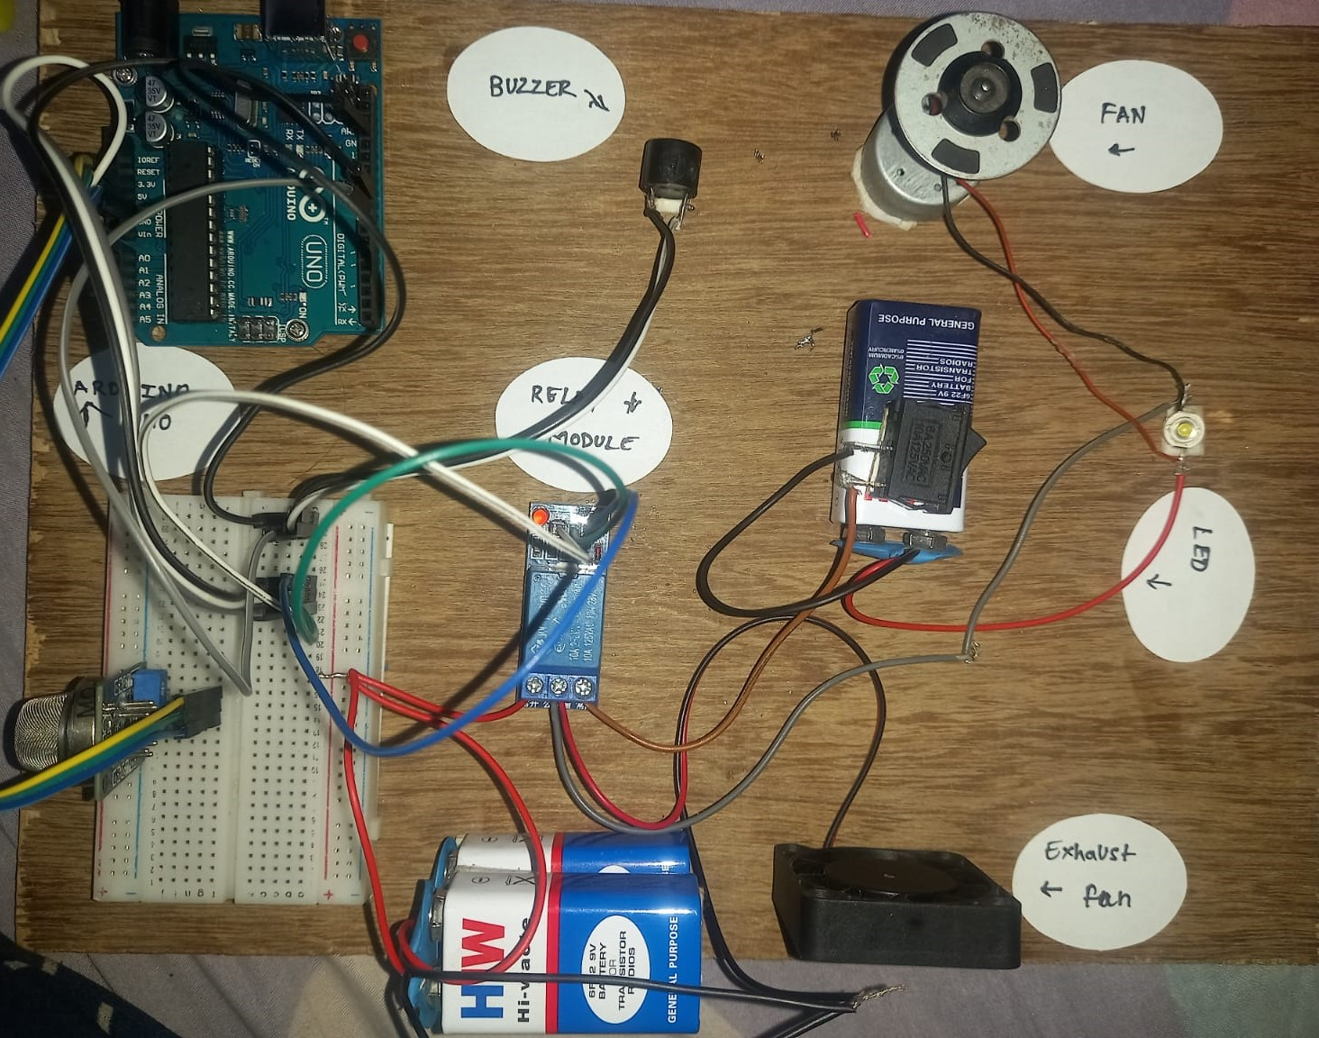

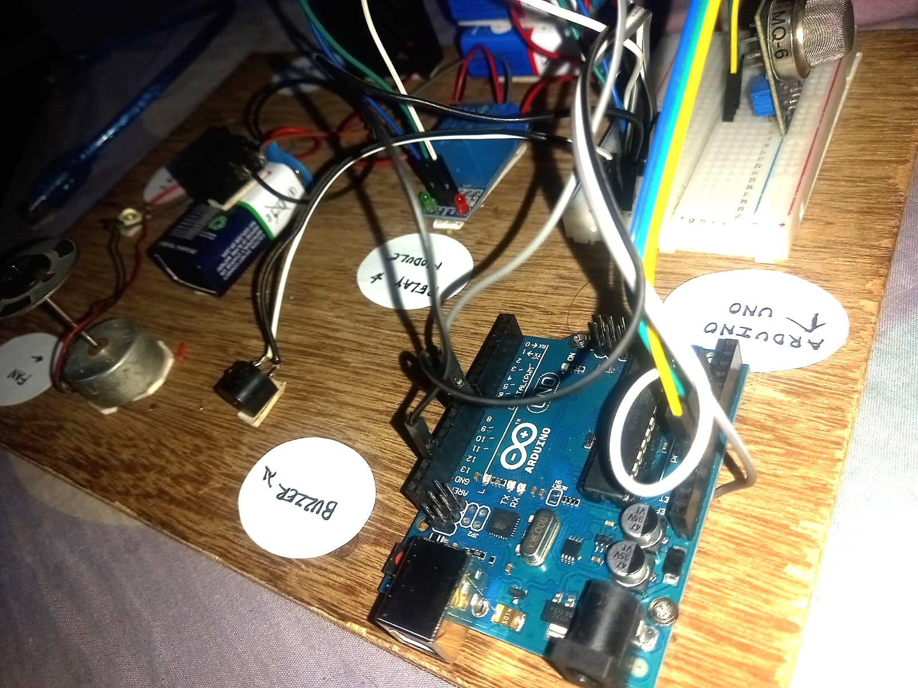

**CONCLUSON**

In conclusion, the gas detection system project utilizing an Arduino, MQ5 gas sensor, relay module, and exhaust fan offers a practical and effective solution for detecting flammable or hazardous gases in various settings. By integrating these components, the system provides real-time gas monitoring, triggering the activation of the exhaust fan when gas concentrations exceed safe thresholds. This proactive approach enhances safety, mitigates potential risks, and protects individuals and properties from the dangers associated with gas leaks or hazardous gas exposure.

The project demonstrates the versatility and capabilities of Arduino microcontrollers and sensors in creating innovative and cost-effective gas detection systems. The MQ5 gas sensor proves to be reliable in detecting target gases, while the relay module and exhaust fan combination ensure swift ventilation in case of gas detection. The integration of these components offers a practical solution that can be customized and scaled based on specific requirements.

The applications of this gas detection system are wide-ranging, spanning from residential and commercial environments to industrial and laboratory settings. Its potential to enhance safety and prevent accidents makes it a valuable addition to gas storage facilities, commercial kitchens, HVAC systems, and more.

Furthermore, the project highlights the importance of proper programming, hardware setup, and adherence to safety standards. Regular maintenance, calibration of the gas sensor, and periodic testing are crucial to ensure the system's accuracy and reliability.

Overall, the gas detection system project using an Arduino, MQ5 gas sensor, relay module, and exhaust fan demonstrates an efficient and practical approach to gas monitoring and safety. By promptly detecting and responding to gas leaks, the system helps safeguard individuals, properties, and the environment, contributing to a safer and more secure living and working environment.

**REFERENCES**

1. YouTube channel – Innovative Ideas

https://www.youtube.com/watch?v=iC-umvkXeFA

**COSTING**

|  |  |  |  |  |
| --- | --- | --- | --- | --- |
| **S.no** | **Component Name** | **Rating** | **Quantity** | **Cost** |
| 1 | Arduino UNO | ATmega328P | 1 | 620 |
| 2 | MQ5 Gas sensor |  | 1 | 120 |
| 3 | Relay Module |  | 1 | 50 |
| 4 | Exhaust fan |  | 1 | 100 |
| 5 | LED | 3V | 1 | 10 |
| 6 | DC Motor | 3.7V | 1 | 30 |
| 7 | BreadBoard |  | 1 | 50 |
| 8 | Jumper Wires |  | 10 | 50 |
| 9 | Wood plateform |  | 1 | 50 |
| 10 | On/Off Switch |  | 1 | 10 |
| 11 | Battery | 9V | 4 | 100 |
| 12 | Buzzer |  | 1 | 20 |
| **Total** | | | | **1210** |

**PROGRAM CODE**

#define Sensor pin = A0;

#define relay pin = D9;

#define Buzzer Pin = D8;

#define sensorDigital A0

#define relay 9

#define buzzer 8

#define sensorAnalog A1

void setup() {

pinMode(sensorDigital, INPUT);

pinMode(relay, OUTPUT);

pinMode(buzzer, OUTPUT);

Serial.begin(9600);

}

void loop() {

bool digital = digitalRead(sensorDigital);

int analog = analogRead(sensorAnalog);

Serial.print("Analog value : ");

Serial.print(analog);

Serial.print("t");

Serial.print("Digital value :");

Serial.println(digital);

if (digital == 0) {

digitalWrite(relay, LOW);

digitalWrite(buzzer, HIGH);

delay(5000);

digitalWrite(relay, HIGH);

digitalWrite(buzzer, LOW);

}

else {

digitalWrite(relay, HIGH);

digitalWrite(buzzer, LOW);

}

}